Project : Create a ASP.NET MVC Project Using c# and .NET frame work in Visual Studio 2019.
- Open visual studio and choose the option Create new project which is highlighted in the below pic.

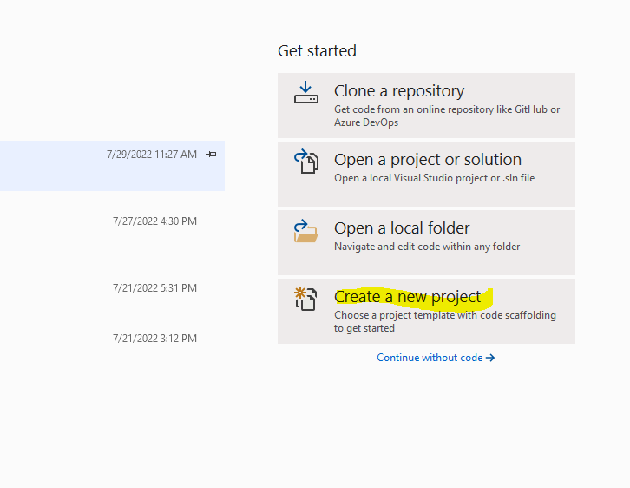

- Search for ASP.NET web application (.NET framework) and choose the project which is represented in the below screenshot

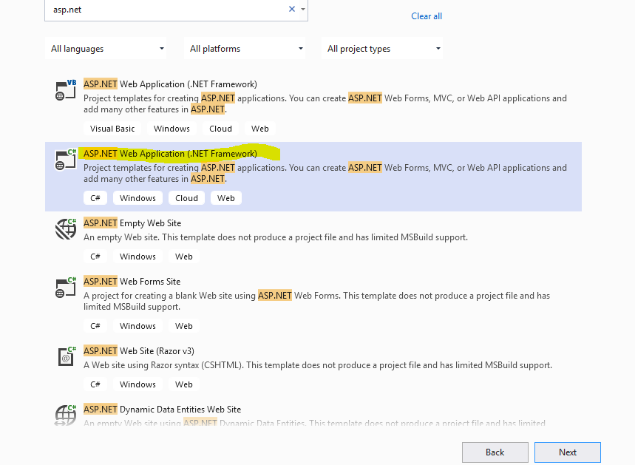

- Named the project as Assignment1

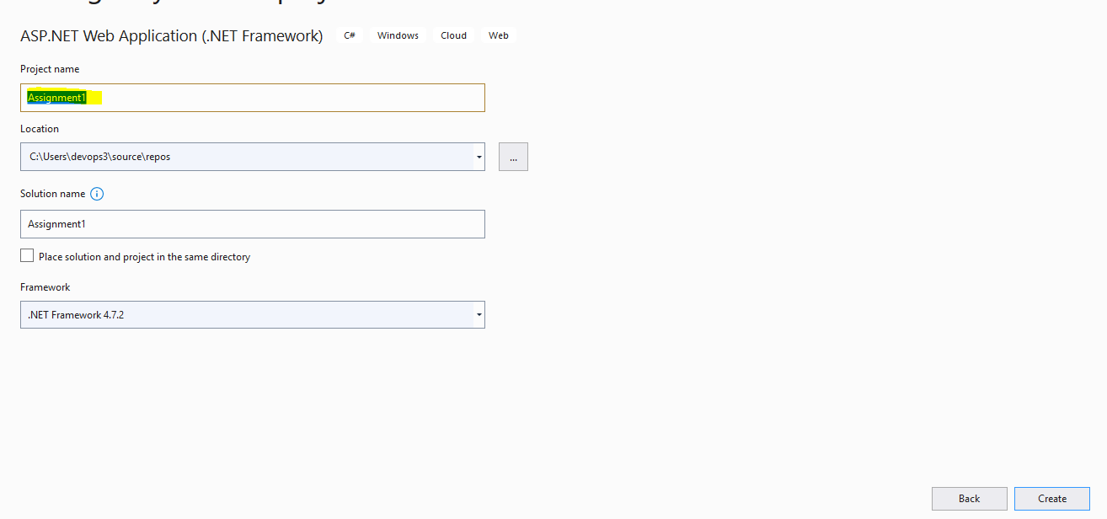
- And choose the MVC Project Template
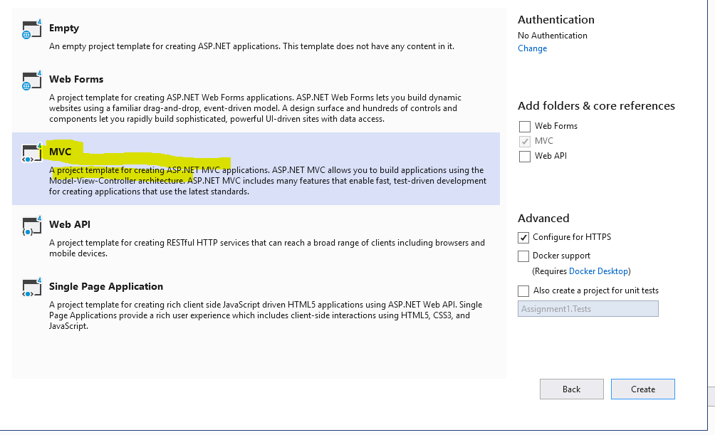
- After the creation of project right click on the project name and choose the option of Unloaded project and remove the commented statements
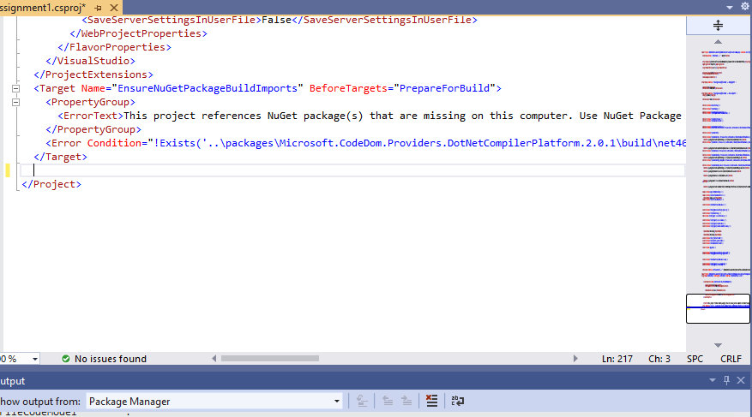

- For this we need to add the code for build and successfully added into the project
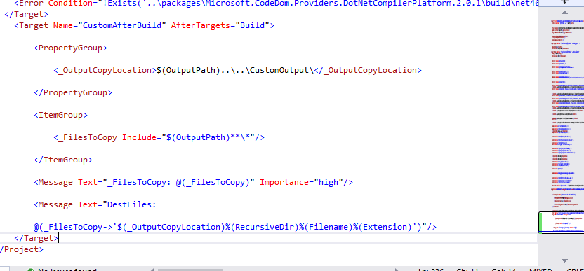
- First go to the project location where it is located through Command developer terminal
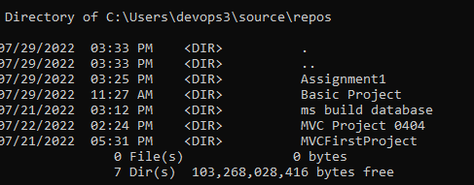

- After coming to the right working directory use dir command and we can see the Assignment1.csproj

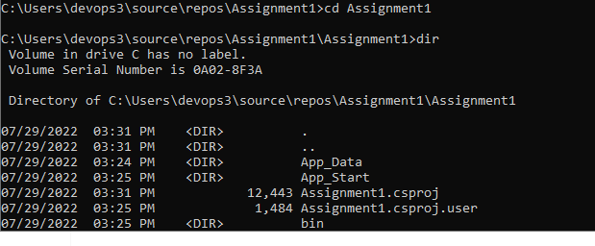
- Then it’s time to execute the build by using the “msbuild Assignment1.csproj –t:Build”
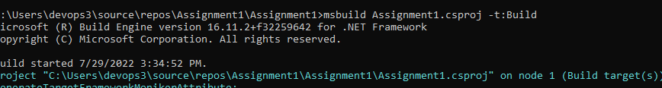

- And the build got success and the output is coming like which is represented in below screenshot

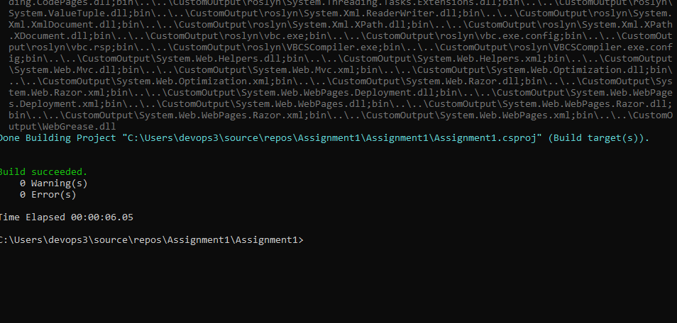
- Like above step we need to clean the build and the code is added into the project

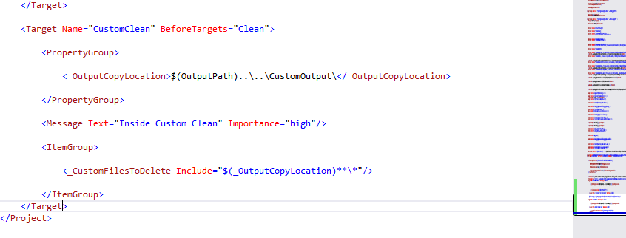

- After adding time time to execute the CustomClean and the output will come as shown in below

